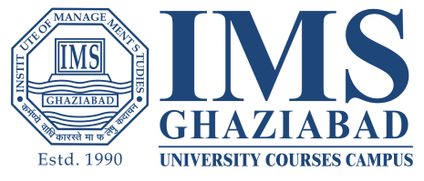‍‍**HIMANSHI SRIVASTAVA**

House no.128 Sector-2 , Chiranjeev Vihar , Ghaziabad , 201002 | 8700756820 | himanshi.srivastava@imsuc.ac.in

Career Objective

A hardworking student pursuing BBA from IMS university courses campus, I seek an internship position that will allow me to explore more career options in retail and marketing field.

Education

* Pursuing Bachelors of Business Administration with Marketing Specialization from Institute of Management Studies University Courses Campus, Ghaziabad
* Completed 12th from K.D.B Public School in May 2018
* Completed 10th from K.D.B Public School in May 2016

Skills

* Can work in a team with proper coordination.
* Active listener.
* Persuasive skills.
* Negotiating skills.
* Willingness to learn more

Industry Academia Participations

* Industrial visit to Amul , organized by IMS , Ghaziabad University Courses Campus on February 11th2019 to witness manufacturing process.
* Attended a startup conclave on February 16th , 2019 .
* Attended Motivational Talk show ( Key To Success by Dr. Surya Narayan Bahadur, organized by IMS, Ghaziabad university courses campus on April 12th
* Visited Mother Dairy to witness Production Process.
* Attended a Seminar on Intellectual Property Rights by CWEI on August 23rd 2019.
* Internship at NIU infratech from 16thJanuary 2020 to 20thFebruary 2020.
* Attended a Marketing Webinar on Changing Face Of Marketing Mix with more focus on New Product Development by Mr. RajkiranKangala on May 23, 2020.
* Currently working as an Affiliate Marketing Manager Intern at 6-Digit Consultancy Services.
* Attended a virtual session by UN GCNI and Vijaybhoomi University.

Co Curricular Activities

* Participated in Markfest , an event organized by IMS University Courses Campus
* Participated in Model United Nation (MUN) as a member of Organizing committee.

LinkedIn Profile - <https://www.linkedin.com/in/himanshi-srivastava-72a000191/>

Date: June 11th 2020